**University of engineering & technology Peshawar**



**CIRCUIT & SYSTEM -1**

**Lab report # 4**

**Fall 2020**

**Submitted by: Ashfaq Ahmad**

**Section: B**

**Reg No: 19PWCSE1795**

**Semester: 2nd**

**Submitted to:**

**Eng: FAIZ ULLAH**

**Department Of Computer System Engineering**

**To verify ohm’s law on breadboard**

1. **OBJECTIVES:**

* To know about ohm’s law its mathematical expression, graphically representation, observation and calculation.
* To know about apparatus used in verification of ohm’s law.

1. **OHM’S LAW**

**Ohm's law** is a **law** that states that the voltage across a resistor is directly proportional to the current flowing through the resistance.

Mathematically:  
 **V= I×R**

**Where R is constant of propstionality and is called resistance.**

V= voltage, I= current and  R= resistance

The SI unit of resistance is **ohms** and is denoted by **Ω**

This law is one of the most basic laws of electricity. It helps to calculate the [power](https://www.toppr.com/guides/physics/work-energy-and-power/power/), efficiency, current, voltage, and resistance of an element of an electrical circuit.

**Circuit diagram:**

Ohm's law can be verified using following circuit diagram,

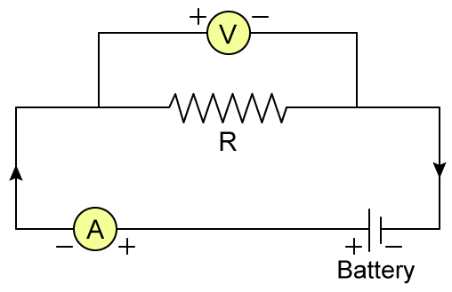

1. **Apparatus:**

* Breadboard
* Power supply
* Connecting wires
* Resisters
* Multimeter

1. **Procedure:**

1. Prepare Breadboard, Adriano, wires, and Multimeter

2. Connect the Adriano to the Breadboard (black wire to the negative, red wire to the positive)

3. Connect 3 resistors horizontally underneath each other

4. Wire up the resistors

5. Connect resistors to the Multimeter (multimeter is NOT connected to the Breadboard)

6. Observe

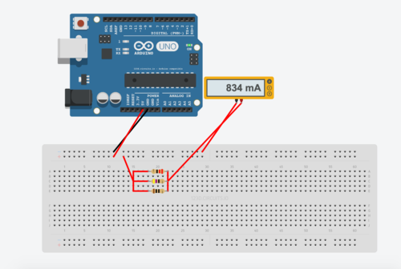

1. **OBSERVATION AND CALCULATION:**

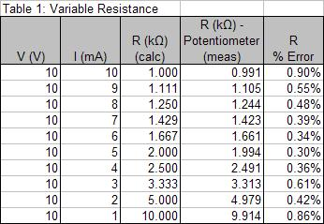

1. **GRAPH:**

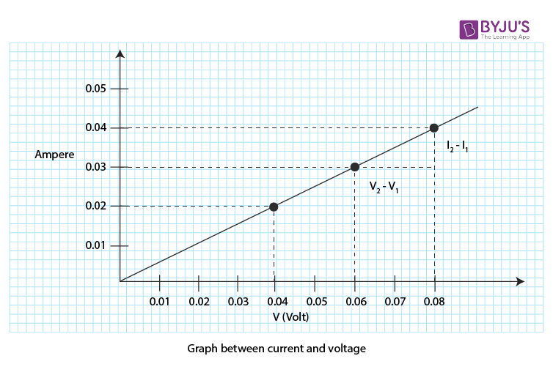

1. **CONCLUSION:**

From The Above Experiment We Conclude That Current In A Circuit Is Directly Propositional To Voltage By Keeping Resistance Constant. THIS is also verified from above graph. From ohm’s law it is cleared that in case of metallic conductor there will be direct relation b/w current and voltage by keeping other physical condition constant.

The end